DAMIEN TALTY’S RESUME

OBJECTIVE
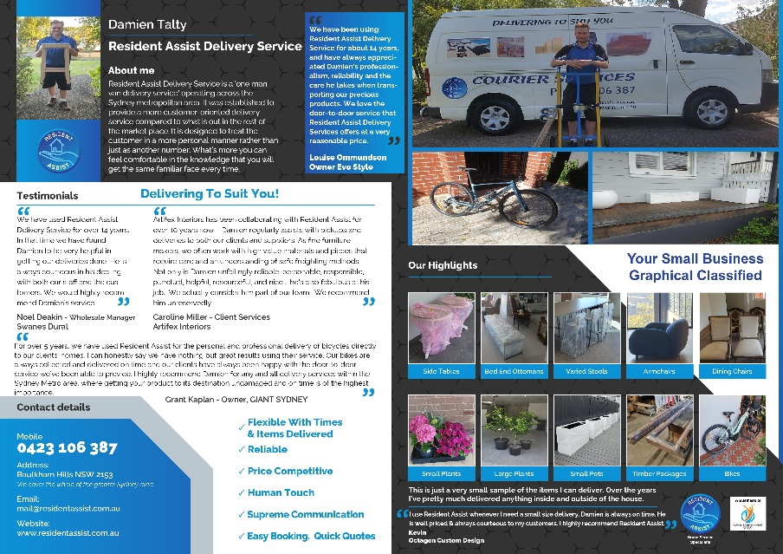
I’ve been operating my own delivery business called Resident Assist Delivery Service for around 19 years as it combines my organising skills, where no day is the same as another combined with delivering great customer service around high end household furniture and yardware items. It basically combined my Administration and Organising skills from HIH Insurance with Logistics and physical handling from Myer / Grace Bros.
AVAILABILITY
- Weekday Afternoons from 2pm onwards to 10pm. I can adapt the start and end times slightly to suit your business needs.
- From 24 to 40 hrs per week.
- Even though 38 hrs is considered Full Time Work, the reality for a small businessperson is that it’s about 50% or halfway.
BEST LOCATIONS FOR WORK
Eastern Creek, Prospect, Pemulway, Seven Hills, Blacktown, Kings Park, Arndell Park, Erskine Park, Rydalmere, Silverwater, Lidcombe.
I operate my delivery service in the morning between 8am and 1pm so most times I will be coming to work direct along the M8 and M4. This is why the locations above are fine as these suburbs are nearby to these central motorways.
- Australian born with full working rights.
- Have my own car.
- Full Drivers Licence. Zero Demerit Points.
- Current National Police Check.
- Working with Children’s Check
- RSAT Certified: Responsible Supply of Alcohol
- First Aid Accreditation

THE REASON WHY I’M INTERESTED IN AFTERNOON / EVENING WORK FOR 8 HOUR SHIFTS:
The economic climate has changed over the last couple of years mainly, and then with the wars going on in the world it has made consumers hesitant about spending money on discretionary items that I’ve delivered for my business. So, I’m looking at doing 8 hr shifts in the afternoon / evening, Monday to Friday for Casual / Ongoing work. I like driving so thought I would resume driving a forklift or similar equipment for work.
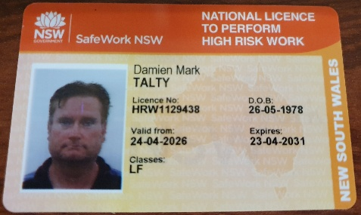

WORK HISTORY & RESPONSIBILITIES
- My Own Business: Resident Assist Delivery Service

LOGISTICS SKILLS
- LF Forklift Licence (HRW1129438). 3 plus years’ experience. Mainly Counterbalance but High Reach as well.
- Recent Order Picker Licence (LO).
- 5 Years Electric Pallet Rider Experience (Picks up 2 pallets on forks).
- Manual Pallet Jacks
- Picking & Packing
- RF Scanning
- Wrapping Pallets
- Stacking /Packing Boxes
- Manual Handling
- Loading & Unloading freight
- Stock Control
- Dispatch
- Warehousing
OTHER SKILLS
- Administration
- Database Management
- Excellent Customer Service.
- Adaptability to changing circumstances.
- Organising / Coordinating tasks amongst large departments (100 plus staff).
- Building Long Lasting Client Relationships.
- Lateral thinking to help resolve problems.
- Teamwork: Collaborating with many different people.

Mid 2007 to Present:
- Built from scratch a “Last Mile Delivery Service” that was unheard of at the time.
- Flexible delivery windows to suit the customer.
- Being the Operator / Organiser and Delivery Person in one.
- Being a familiar face for relationship building. Have existing relationships for 15 plus years.
- No account setup needed. Mutual trust.
- Making bookings easy so that they can be organised in about 30 seconds because tape measures, scales etc are not needed.
- Extensive knowledge of the Sydney Metro area but also Blue Mountains and Hunter Valley. I’ve had horses in both locations.

- Logistics and Warehouse Coordinator, Myer Castle Hill

October 2002 to March 2007

Main Tasks Included:
- Coordinating / Organising
- Worked as part of a team of 3, responsible for all stock being transported in and out of the store (Myer, 10 to 20 trucks a day). Liaising with 100 plus staff members from other departments beyond the dock team.
- Book local and interstate truck scheduling
- Following strict store compliance when processing paperwork (Myer)
- ER & D (Electronic Receiving & Dispatch of stock with scanner).
- Leadership
- Active Logistics Team Leader (Myer) when superior was away.
- Teaching new recruits, the standards needed for the roles that they have been successful in getting.

- HIH Insurance Roles, Workers Compensation Division 1999 to 2001
EDUCATION / QUALIFICATIONS
- Diploma of Business Management, Metropolitan Business College, 18th December 1998.
- Diploma of Sports Marketing, APM Training Institute (Course Conducted in 2002), 28th March 2003 received certificate.
- Certificate 3 in Travel - Travel Agent Qualification, 22nd March 2017
- Certificate 4 in Fitness - Personal Trainers Qualification, 20th March 2013

AWARDS
(1) Employee of the Month December 2003. Myer Certificate of Recognition: “Outstanding support to accommodate stock movement throughout the store daily, during the busiest time of the year.
(2) Liaise with department leaders on new store developments. Myer Certificate of Recognition: 10th May 2006, building and maintaining effective working relationships with stakeholders.

* HIH went into administration but sold its Workers Compensation Division to IAG where all workers retained existing roles.
Date: February 2000 to August 2001
Summary of Duties: Giving Support to around 150 people in the Workers Compensation Division through a broad spectrum of duties.
- Coordinating / Organising
- Archival Management (Recall)
- BDC (IT Support Role). Logging calls regarding computer problems / assigning passwords for new members.
- Detect and log calls for office machine malfunctions
- Function Coordinating – Board room assembly for seminars and conferences
- Internal Auditing
- Make sure that files complied with WorkCover regulations.
- Date Entry – entering results based on file findings
- Producing charts and graphs based on section results

- Procurement / Ordered
- Office stationery
- Toners for faxes, photocopiers and printers
- Office transportation
- Office Furniture
- Drinks ordering for monthly celebrations
- Archival Management (Recall)

- Coordinating / Organising
- Archival Management (Recall)
- BDC (IT Support Role). Logging calls regarding computer problems / assigning passwords for new members.
- Detect and log calls for office machine malfunctions
- Function Coordinating – Board room assembly for seminars and conferences
- Coordinated and trained team members on the processes of archival management

- Factory and Yard Hand Worker, Tenlow Tool & Engineering (My Dads Toolmaking Business).
From: 1996 to 1999
Main tasks using Toyota Counterbalance Forklift:
- Loading and Unloading pallets from trucks to warehouse for incoming and outgoing equipment
- Strapping non typical goods to pallets as well as standard sized pallets (600mm Load Centre Distance).

- Moving Various raw materials from one area of factory to another.
REFERENCES
- Noel Deakin - Swanes Commercial Manager, Dural NSW. Relationship from 2010 to present.
Mobile: 0417 792 637

- Mark Engall - Owner of Engalls Nursery, Dural NSW. Relationship from 2011 to present. Mobile: 0412 909 579

- Louise Ommundson, Evo Style Director. Sensitive Furniture. Relationship from 2009 to present.

- Move completed tools / projects from 1 stage to another stage in factory.
- High Racking of pallets was done when storing bolts or small metal tools in boxes that were custom
ordered.
- Plastic wrapping pallets in preparation for dispatch.

RECENT TEMPORARY WORK
Date: March 2026 to June 2026, Ongoing.
Company: ASAP Recruitment / Client: Best and Less
Title: Casual Process Worker / Electric Pallet Rider
- 8 weeks of work at Best and Less Distribution Centre at Eastern Creek between 2pm and 10pm across Monday to Friday.
- I’m mainly used to help distribute pallets of incoming stock from dock areas to other parts of the warehouse in to designated areas on electric pallet riders where these machines pickup 2 x pallets at a time.
Because clothing is seasonal this distribution centre has peaks and troughs (Winter Stock & Summer Stock) and they are going back to a 1 x 8-hour shift when they had 3 x 8-hour shifts going back only 4 weeks ago. I’m looking for work that is more constant throughout the year so that ongoing relationships and my full skill set can be utilised appropriately.
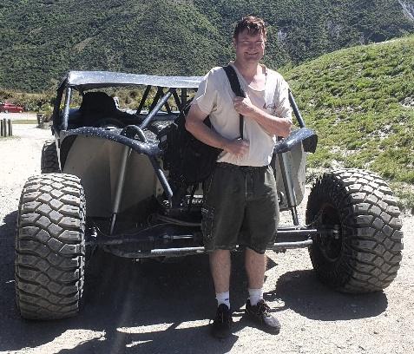
SEE MY DEDICATED WEBSITE WHERE YOU WILL FIND DOCUMENTS AND INFORMATION THAT VALIDATES WHAT I’VE PUT IN THIS RESUME AND PROVIDES GREATER CONTEXT / DEPTH THAN WHAT A RESUME OR LETTER CAN PROVIDE ON THEIR OWN.
www.damientaltyprofile.online

